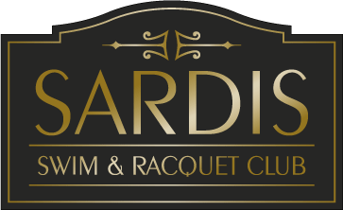 2019 Operating Hours

Date | Pool Hours | Concession Hours
May 18th | 11–6pm | 11–6pm
May 19th | 12-6pm | 12-6pm
May 20t – 24th | 2-4pm | 4-6pm
May 25th | 11-8pm | 11-6pm
May 26th | 12-8pm | 12-6pm
May 27th (Memorial Day) | 11-6pm | 11-6pm
May29th – 31 1st | 11 -4pm | 4-6pm
June 1st | 11-8pm | 11-7pm
June 2nd | 12-8pm | 12-7pm
June 3rd – 7th | 11-4pm (June 7th 6:30 -10:00pm) | 4-7pm June 7th ,8pm)
June 8th | 10 -10pm | 11-8pm
Regular Season Hours
June 9th – August 23rd | 11-9pm Mon-Sat (Fri & Sat til  10pm) Sun 12-9pm | 11-7pm Mon –Sat (Fri til 8pm)  Sun 12 -7pm
August 25th –Sept 15th | 2-7pm Mon-Thur (Fri til 8pm)  Sat 11- 8pm Sun 12-7pm | 3-6pm Mon- Thur (Fri til 7pm)  Sat 11-6pm  Sun 12-6pm
Special Dates:
July 4th | 11 -6pm | 11-6pm
August 24th ( Adult party) | 11-4pm | 11-4pm
September 3rd(Labor Day) | 11-7pm | 11-6pm
Exceptions to the above pool hours
*The pool will open @ 10:00 am Monday thru Friday once the swim & dive teams have completed their seasons (usually after the first week in July)
*Pool may be open weekends after September 15th – weather permitting and staff availability *August 24th Adult party, pool closes @ 4:00 pm
*The pool will close at 4:30pm when a HOME Swim or Dive meet is scheduled. Please check the bulletin board or website for these dates. We will share this information as soon as dates are available
*The children’s pools are open at all times during pool hours. Parents may use the children’s pools during swim and dive practices only. During HOME meets, these pools are closed.

